**CS 553: Cloud Computing**

**Understanding the Cost of Computing in the Cloud**

**Hariprasad Ravi Kumar**

**A20348609**

Abstract—The main purpose of this project is to grasp the importance of economic concerns regarding cloud computing. Since cloud computing becomes widespread within the industry of computer science, the management of prices has become a huge topic of cloud computing these years. We are to study the incentives of setting up a public rather than a private cloud.



The above table describes about the ec2 instances of AWS. We use the concept of EC2 compute units to denote the compute capacity in Gflops of each instance. Each VCPU of the instance is a hyper thread of the Intel Xeon processor. We consider seven instances prm4.10xlarge, prm3.large, prm3.2xlarge, prc3.8xlarge, prg2.2xlarge, prr3.4xlarge, pri2.8xlarge and prd2.8xlarge which are compared to the amazon ec2 instances m4.10xlarge, m3.large, m3.2xlarge, c3.8xlarge, g2.2xlarge, r3.4xlarge, i2.8xlarge, and d2.8xlarge. We build a private cloud for all the amazon instances and compare the cost of each instance per hour. To build a private cloud the factors we consider are Processor, Storage, Memory, Network Adapter, Network Switch, System Admin, Cooling Power, Chassis, Rack, UPS, Motherboard. We consider building a private cloud from the scratch. While building the private cloud we check the compatibility of the hardware with the other factors. The total mentioned in the table is the cost of the instance amortized for 5 years. All the considered processors support hyper threading and while considering GFlops we also multiply the number of hyper threads which is 2 to the number of cores * instructions per cycle * processor speed.

**Private Instances:**

**1. prm4.10xlarge**

|  |  |  |
| --- | --- | --- |
| **Device** | **Details** | **Cost** |
| Processor Cost | 2 Intel Xeon E5-2676 v3 12 Core 2.4GHz | $3,600 |
| Storage | Western Digital Caviar Blue 640 GB Bulk/OEM Hard Drive 3.5 Inch, 16 MB Cache, 7200 RPM SATA II WD6400AAKS | $133.89 |
| Memory | 8*20 GB DDR4 | $8000.00 |
| Network  Adapter | Intel Ethernet Server Adapter I350-T2 1gbps | $129.99 |
| Network Switch | 18 ports Linksys | $306.87 |
| Cooling Power | 399.42 | $2,921.60 |
| Chassis | 2U SC823TQ-653LPB 650W | $370.27 |
| Rack | 42u Rack | $70.00 |
| UPS | APC Smart-UPS SMC1500-2U 900w 6 outlets | $464.98 |
| Motherboard | SUPERMICRO X9SRL-F ATX Server Motherboard LGA 2011  DDR3 | $270.99 |
| Adapter | ICY DOCK EZConvert MB882SP-1S-2B 2.5" to 3.5" SATA 6Gbps  SSD | $37.73 |
|  |  |  |
| Total |  | $16,306 |

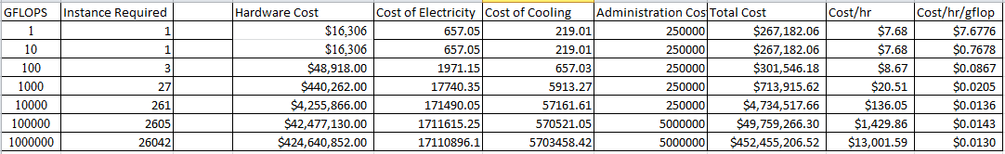

This instance is specific for general purpose computing. The prm4.10xlarge has a 24 core processor which can be shared between 24 instances implies we dedicate 1 core to each instance. The memory, storage, chassis, rack, motherboard are also considered to fit 24 instances. The adapter is considered because the tray size is 3.5 but the SSD is only 2.5 so, we put the SSD in the adapter and put this in the rack. We calculate the Gflops of this private instance it is 2*2.4*12*4*2=460.8, so each instance has a compute capacity of 38.4 Gflops.

**2. prm3.large**

|  |  |  |
| --- | --- | --- |
| **Device** | **Details** | **Cost** |
| Processor Cost | Intel Xeon E5-2670 v2 Ivy Bridge-EP 2.5 GHz 25MB L3 Cache | $1,559.99 |
| Storage | (TS32GMSA370) mSATA 32GB SATA III MLC Internal (SSD) | $38.99 |
| Memory | Kingston 8GB 240-Pin DDR3 | $31.99 |
| Network  Adapter | Intel Ethernet Server Adapter I350-T2 1gbps | $129.99 |
| Network Switch | 18 ports Infiniband | $306.87 |
| Cooling Power | 399.42 | $2,921.60 |
| Chassis | 2U SC823TQ-653LPB 650W | $370.27 |
| Rack | 42u Rack | $70.00 |
| UPS | APC Smart-UPS SMC1500-2U 900w 6 outlets | $464.98 |
| Motherboard | SUPERMICRO X9SRL-F ATX Server Motherboard LGA 2011  DDR3 | $270.99 |
| Adapter | ICY DOCK EZConvert MB882SP-1S-2B 2.5" to 3.5" SATA 6Gbps  SSD | $37.73 |
|  |  |  |
| Total |  | $6,203.40 |

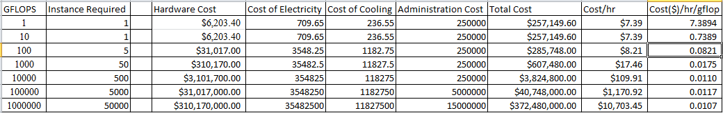

This instance is specific for general purpose computing. The prm3.large has an 8 core processor which can be shared between 8 instances implies we dedicate 1 core to each instance. The memory, storage, chassis, rack, motherboard are also considered to fit 8 instances. . The adapter is considered because the tray size is 3.5 but the SSD is only 2.5 so, we put the SSD in the adapter and put this in the rack. We calculate the Gflops of this private instance it is 2*2.5*8*4=160, so each instance has a compute capacity of 20 Gflops.

**3. prm3.2xlarge**

|  |  |  |
| --- | --- | --- |
| **Device** | **Details** | **Cost** |
| Processor Cost | Intel Xeon E5-2670 v2 10 Core 2.5GHz | $1,675.99 |
| Storage | Intel DC S3500 Series 2.5" 160GB SATA III MLC Internal SSD | $159.99 |
| Memory | Kingston 32GB 240-Pin DDR3 | $281.37 |
| Network  Adapter | Intel Ethernet Server Adapter I350-T2 1gbps | $129.99 |
| Network Switch | Cisco SG200-18 Switch 16 10/100/1000 Ports, Gigabit Ethernet | $273.00 |
| Cooling Power | 464.22 | $3,402.10 |
| Chassis | SuperChasis 825TQ-600WB 2U | $349.99 |
| Rack | 42u Rack | $70.00 |
| Motherboard | ASRock EP2C602-2T/D16 SSI EEB Server Motherboard Dual LGA  2011 DDR3 1600/1333/1066 | $499.99 |
| UPS | APC Smart-UPS SMC1500-2U 900w 6 outlets | $529.99 |
| Adapter | ICY DOCK EZConvert MB882SP-1S-2B 2.5" to 3.5" SATA 6Gbps  SSD | $24.99 |
|  |  |  |
| Total |  | $7,397.40 |

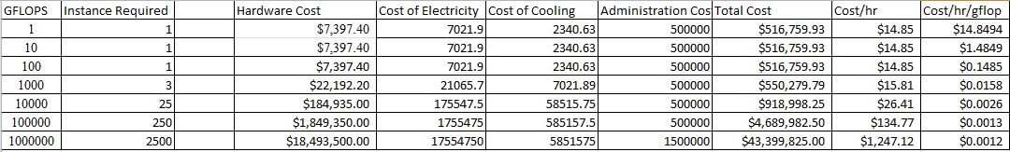

This instance is compute optimized with high performing processors. The prm3.2xlarge has a 10 core processor. Each instance is allocated 10 cores. So we take 10core processor and for memory we take 32GB DDR3 RAM’s. When we calculate the Gflops of this private instance it is 2*2.5*10*4*2=400, so each instance has a compute capacity of 400 Gflops.

**4. prc3.8xlarge:**

|  |  |  |
| --- | --- | --- |
| **Device** | **Details** | **Cost** |
| Processor Cost | 2 Intel Xeon E5-2680 v2 Ivy Bridge-EP 2.8 GHz | $3,539.99 |
| Storage | Western Digital Caviar Blue 640 GB Bulk/OEM Hard Drive 3.5 Inch, 16 MB Cache, 7200 RPM SATA II WD6400AAKS | $133.89 |
| Memory | 8*8 GB DDR3 | $329.99 |
| Network  Adapter | Intel E10G42BT X520-T2 10Gigabit Ethernet Card 10Gbps | $503.38 |
| Network Switch | Cisco SG200-18 Switch 16 10/100/1000 Ports, Gigabit Ethernet | $273.00 |
| Cooling Power | 464.22 | $3,402.10 |
| Chassis | SuperChasis 825TQ-600WB 2U | $349.99 |
| Rack | 42u Rack | $70.00 |
| Motherboard | ASRock EP2C602-2T/D16 SSI EEB Server Motherboard Dual LGA  2011 DDR3 1600/1333/1066 | $499.99 |
| UPS | APC Smart-UPS SMC1500-2U 900w 6 outlets | $529.99 |
| Adapter | ICY DOCK EZConvert MB882SP-1S-2B 2.5" to 3.5" SATA 6Gbps  SSD | $24.99 |
|  |  |  |
| Total |  | $9,657.31 |

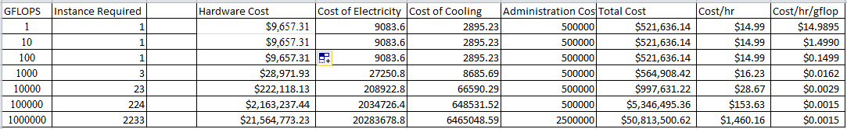

This instance is compute optimized with high performing processors. The prc3.8xlarge has a 20 core processor. Each instance is allocated 20 cores. So we take two 10 core processors and for memory we take eight 8GB DDR3 RAM’s. When we calculate the Gflops of this private instance it is 2*2.8*10*4*2=448, so each instance has a compute capacity of 448 Gflops.

# 5. prg2.2xlarge:

|  |  |  |
| --- | --- | --- |
| **Device** | **Details** | **Cost** |
| Processor Cost | Intel Xeon E5-2670 8 Core 2.6GHz | $1,349.95 |
| Storage | 64GB SATA III 6Gb/s SSD | $109.99 |
| Memory | 8*2 GB DDR3 | $69.99 |
| Network  Adapter | Intel E10G42BT X520-T2 10Gigabit Ethernet Card 10Gbps | $503.38 |
| Network Switch | Cisco SG200-18 Switch 16 10/100/1000 Ports, Gigabit Ethernet | $273.00 |
| Cooling Power | 576.72 | $4,218.48 |
| Chassis | 2U SC823TQ-653LPB 650W | $360.41 |
| Rack | 42u Rack | $70.00 |
| UPS | APC Smart-UPS SMC1500-2U 900w 6 outlets | $529.99 |
| Adapter | ICY DOCK EZConvert MB882SP-1S-2B 2.5" to 3.5" SATA 6Gbps  SSD | $24.99 |
| Motherboard | ASUS Z9PE-D16 SSI EEB Server Motherboard Dual LGA 2011  DDR3 1600 | $499.99 |
| GPU | NVIDIA TESLA K20 3.52 Tflops Workstation Video Card - OEM | $2,899.99 |
|  |  |  |
| Total |  | $8,010.17 |

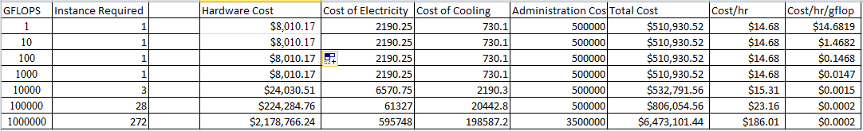

This instance is intended for GPU computations with high performance NVIDIA TESLA K20 with Tflops. The prg2.2xlarge has an 8 core processor and the number of cores for the gpu processor is 2496 cores. For compute capacity we consider the gflops of both cpu and gpu. Cpu single precision performance = 166.4 GFLOPS, Gpu single precision performance = 3520 GFLOPS. TOTAL GFLOPS= 3686.4

**6. prr3.4xlarge:**

|  |  |  |
| --- | --- | --- |
| **Device** | **Details** | **Cost** |
| Processor Cost | Intel Xeon E5-2670 v2 10 Core 2.5GHz | $1,675.99 |
| Storage | 320GB SSD | $94.89 |
| Memory | 128GB DDR3 | $1,059.00 |
| Network Adapter | QLogic QLE3242-CU-CK 10Gbps PCI Express Gen2 x8 Dual Ethernet | $489.89 |
| Network Switch | Cisco SG200-18 Switch 16 10/100/1000 Ports, Gigabit Ethernet | $273.00 |
| Cooling Power | 416.22 | $3,042.87 |
| Chassis | SC 514-R400c 1U | $463.21 |
| Rack | 42u Rack | $70.00 |
| Motherboard | ASUS rampage IV black edition LGA 2011 ETAX | $374.99 |
| UPS | APC Smart-UPS SMC1500-2U 900w 6 outlets | $489.99 |
| Adapter | ICY DOCK EZConvert MB882SP-1S-2B 2.5" to 3.5" SATA 6Gbps SSD | $46.99 |
|  |  |  |
| Total |  | $8,080.82 |

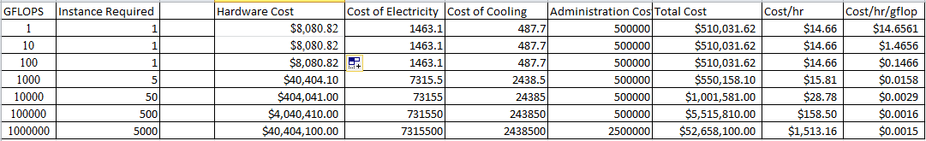

This instance is intended for memory intensive applications. The prr3.4xlarge has a 10 core processor. Each instance is allocated 10 cores. The RAM is 128 GB DDR3. When we calculate the Gflops of this private instance it is 2*2.5*10*4=200, so each instance has a compute capacity of 200 Gflops.

**7. pri2.8xlarge:**

|  |  |  |
| --- | --- | --- |
| **Device** | **Details** | **Cost** |
| Processor Cost | IBM 2.5GHz 16 MB L2 Cache 20MB L3 Cache Socket G34 115W Server  Processor 00AM123[16-core] (3P) | $4,762.65 |
| Storage | 8 Intel SSD DC S3500 Series SSDSC2BB800G401 2.5" 800GB SATA III MLC Internal Solid State Drive (SSD) | $6,039.92 |
| Memory | 8*(4*8) GB DDR3 quad channel ram | $1,359.92 |
| Network Adapter | Intel E10G42BT X520-T2 10Gigabit Ethernet Card 10Gbps PCI Express x8 2 x RJ45 | $503.38 |
| Network Switch | Cisco SG200-18 Switch 16 10/100/1000 Ports, Gigabit Ethernet | $273.00 |
| Cooling Power | 560.22 | $1,639.11 |
| Chassis | Supermicro CSE-826BAC4-R920WB 2U 920W Chassis | $1,199.99 |
| Rack | 42u Rack | $70.00 |
| Motherboard | EP2C602-2T/D16 ASRock Dual LGA2011 Intel C602 DDR3 SATA3 | $922.65 |
| Ups | APC Smart-UPS SMC1500-2U 900w 6 outlets | $489.99 |
| Adapter | ICY DOCK EZConvert MB882SP-1S-2B 2.5" to 3.5" SATA 6Gbps SSD | $46.99 |
|  |  |  |
| Total |  | $17,307.60 |

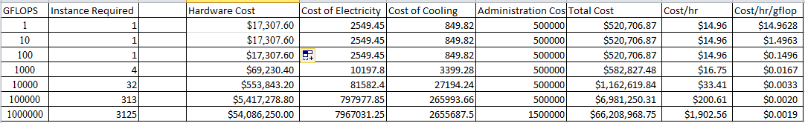

This instance is storage optimized with high FLOPS that is used for random IO operations. The pri2.8xlarge has a 16 core processor. Each instance is allocated 16 cores. So we take eight 32 GB DDR3 RAM’s. The storage is 6TB. When we calculate the Gflops of this private instance it is 2*2.5*16*4=320, so each instance has a compute capacity of 320 Gflops.

# 8. prd2.8xlarge:

|  |  |  |
| --- | --- | --- |
| **Device** | **Details** | **Cost** |
| Processor Cost | 3 Intel Xeon E5-2676 v3 12 Core 2.4GHz | $5,400.00 |
| Storage | Seagate Constellation CS ST2000NC001 2TB 64MB Cache SATA 6.0Gb/s 3.5" Enterprise Internal Hard Drive Bare Drive | $3,167.76 |
| Memory | 8*(4*8) GB DDR3 quad channel ram | $1,359.92 |
| Network Adapter | Intel E10G42BT X520-T2 10Gigabit Ethernet Card 10Gbps PCI Express x8 2 x RJ45 | $503.38 |
| Network Switch | Cisco SG200-18 Switch 16 10/100/1000 Ports, Gigabit Ethernet  1U | $273.00 |
| Cooling Power | 497 | $3,635.00 |
| Chassis | Supermicro CSE-826BAC4-R920WB 2U 920W Chassis | $1,199.99 |
| Rack | 42u Rack | $70.00 |
| Motherboard | EP2C602-2T/D16 ASRock Dual LGA2011 Intel C602 DDR3 SATA3 | $922.65 |
| ups | APC Smart-UPS SMC1500-2U 900w 6 outlets | $489.99 |
| Adapter | ICY DOCK EZConvert MB882SP-1S-2B 2.5" to 3.5" SATA | $46.99 |
|  |  |  |
| Total |  | $17,068.68 |

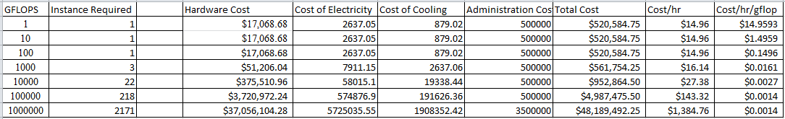

This instance is storage optimized with high storage density. The storage is 24*2 TB. The pri2.8xlarge has a 12 core processor. Each instance is allocated 36 cores. So we take three 12core processors and for memory we take eight 32 GB DDR3 RAM’s. When we calculate the Gflops of this private instance it is 2*2.4*8*4*3=460.8, so each instance has a compute capacity of 460.8 Gflops.

**Cost Comparison of Public Cloud(AMAZON) vs. Private Cloud:**

**Plot 1:**

|  |  |  |  |  |  |  |  |
| --- | --- | --- | --- | --- | --- | --- | --- |
|  | **1** | **10** | **100** | **1000** | **10000** | **100000** | **1000000** |
| m4.10xlarge | 2.394 | 2.394 | 2.394 | 2.394 | 2.394 | 2.394 | 2.394 |
| m3.large | 0.133 | 0.133 | 0.133 | 0.133 | 0.133 | 0.133 | 0.133 |
| m3.2xlarge | 0.532 | 0.532 | 0.532 | 0.532 | 0.532 | 0.532 | 0.532 |
| c3.8xlarge | 1.680 | 1.680 | 1.680 | 1.680 | 1.680 | 1.680 | 1.680 |
| g2.2xlarge | 0.650 | 0.650 | 0.650 | 0.650 | 0.650 | 0.650 | 0.650 |
| r3.4xlarge | 1.330 | 1.330 | 1.330 | 1.330 | 1.330 | 1.330 | 1.330 |
| i2.8xlarge | 6.820 | 6.820 | 6.820 | 6.820 | 6.820 | 6.820 | 6.820 |
| d2.8xlarge | 5.520 | 5.520 | 5.520 | 5.520 | 5.520 | 5.520 | 5.520 |
| prm4.10xlarge | 7.6776 | 0.7678 | 0.0867 | 0.0205 | 0.0136 | 0.0143 | 0.0130 |
| prm3.large | 7.3894 | 0.7389 | 0.0821 | 0.0175 | 0.0110 | 0.0117 | 0.0107 |
| prm3.2xlarge | 14.8494 | 1.4849 | 0.1485 | 0.0158 | 0.0026 | 0.0013 | 0.0012 |
| prc3.8xlarge | 14.9895 | 1.4990 | 0.1499 | 0.0162 | 0.0029 | 0.0015 | 0.0015 |
| prg2.2xlarge | 14.6819 | 1.4682 | 0.1468 | 0.0147 | 0.0015 | 0.0002 | 0.0002 |
| prr3.4xlarge | 14.6561 | 1.4656 | 0.1466 | 0.0158 | 0.0029 | 0.0016 | 0.0015 |
| pri2.8xlarge | 14.9628 | 1.4963 | 0.1496 | 0.0167 | 0.0033 | 0.0020 | 0.0019 |
| prd2.8xlarge | 14.9593 | 1.4959 | 0.1496 | 0.0161 | 0.0027 | 0.0014 | 0.0014 |

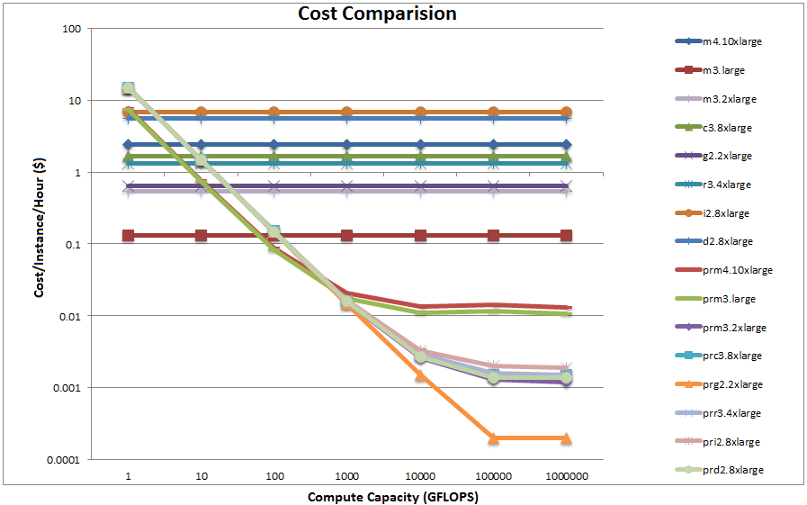

The above graph shows the cost per instance per hour in dollars for each of the amazon instances and the private cloud across 1Gflop to 1PFlop. The instance prm3.large is never cost effective to buy compared to the amazon small instances. It is observed that as the compute capacity is scaled from 1GFLOP to 1PFLOP, the cost per instance per hour decreases gradually, as the initial administration cost and other fixed costs are amortized.

# Plot 2:

|  |  |  |  |  |  |  |  |
| --- | --- | --- | --- | --- | --- | --- | --- |
|  | **1** | **10** | **100** | **1000** | **10000** | **100000** | **1000000** |
| prm4.10xlarge | 264745 | 26476 | 2990 | 707 | 469 | 493 | 448 |
| prm3.large | 1172921 | 117286 | 13032 | 2778 | 1746 | 1857 | 1698 |
| prm3.2xlarge | 512048 | 51203 | 5121 | 545 | 90 | 45 | 41 |
| prc3.8xlarge | 356893 | 35690 | 3569 | 386 | 69 | 36 | 36 |
| prg2.2xlarge | 407831 | 40783 | 4078 | 408 | 42 | 6 | 6 |
| prr3.4xlarge | 212407 | 21241 | 2125 | 229 | 42 | 23 | 22 |
| pri2.8xlarge | 68013 | 6801 | 680 | 76 | 15 | 9 | 9 |
| prd2.8xlarge | 196833 | 19683 | 1968 | 212 | 36 | 18 | 18 |

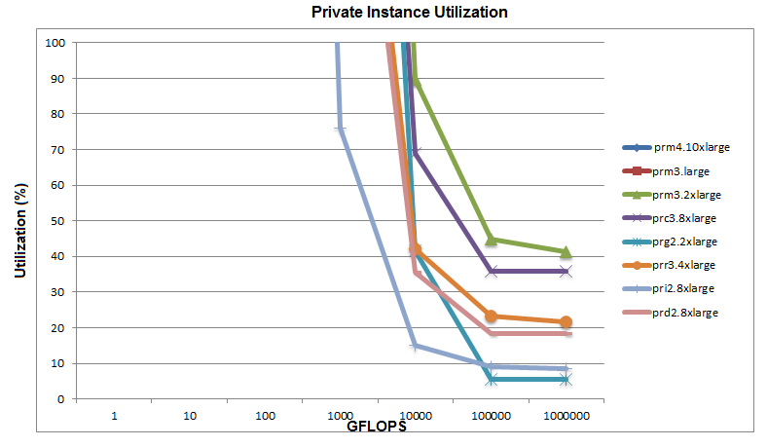

The above plot depicts the utilization of the private cloud as the compute capacity is scaled from 1GFLOP to 1PFLOP. It describes how much of the private instances are used to break-even the cost. The instance prm3.large is not cheap enough to buy compared to what amazon EC2 has to offer.

The prm3.2xlarge instance breaks even between10000Gflops and 100000GFlops. At 100Tflop the utilization is 90% which means if it is recommended to buy this instance if the work load present uses more than 90% of the instance compute capacity. At 1PFlop the utilization is 41% which means if it is recommended to buy this instance if the work load present uses more than 41% of the instance compute capacity.

The prc3.8large instance breaks even between10000Gflops and 100000GFlops. At 100Tflop the utilization is 69% which means if it is recommended to buy this instance if the work load present uses more than 69% of the instance compute capacity. At 1PFlop the utilization is 36% which means if it is recommended to buy this instance if the work load present uses more than 36% of the instance compute capacity.

The prg2.2xlarge GPU instance is utilized 6% around 1Pflop.

The prr3.4xlarge memory instance breaks even between 10000Gflops to 100000Gflops. At 100Tflop the utilization is 42% which means if it is recommended to buy this instance if the work load present uses more than 42% of the instance compute capacity. At 1PFlop the utilization is 22% which means if it is recommended to buy this instance if the work load present uses more than 22% of the instance compute capacity.

The pri2.8xlarge storage optimized instance breaks even round 100GFlops. At 10Tflop the utilization is 15% which means if it is recommended to buy this instance if the work load present uses more than 15% of the instance compute capacity. At 100TFlop the utilization is 9% which means if it is recommended to buy this instance if the work load present uses more than 9% of the instance compute capacity. At 1PFlop the utilization is 9% which means if it is recommended to buy this instance if the work load present uses more than 9% of the instance compute capacity.

The prd.8xlarge storage optimized instance breaks even between 1000Gflops and 10000GFlops. At 10Tflop the utilization is 36% which means if it is recommended to buy this instance if the work load present uses more than 36% of the instance compute capacity. At 100TFlop the utilization is 18% which means if it is recommended to buy this instance if the work load present uses more than 18% of the instance compute capacity. At 1PFlop the utilization is 18% which means if it is recommended to buy this instance if the work load present uses more than 18% of the instance compute capacity.

**References:**

* + - <http://aws.amazon.com/ec2/pricing/>
    - [http://newegg.com](http://newegg.com/)
    - <http://www.newegg.com/Product/Product.aspx?Item=N82E16820233232>
    - <http://www.amazon.com/Intel-E5-2670-2-60Ghz-8-Core-Processor/dp/B007H29FRS>
    - <https://pcpartpicker.com/parts/case/?compatible_with=qlogic-wired-network-card-qle3242cuck>
    - <http://www.shopblt.com/cgi->bin/shop/shop.cgi?action=thispage&thispage=01100500U0124_BXR8117P.shtml&order_id=!ORDERID!
    - https://pcpartpicker.com/part/asus-motherboard-rampageivblackedition
    - [http://www.pricewatch.com/browse/cases_and_accessories/merchant,newegg.com/merchant,atacom_inc./b](http://www.pricewatch.com/browse/cases_and_accessories/merchant%2Cnewegg.com/merchant%2Catacom_inc./b) rand,ultra_computer_products/621
    - <http://www.thomas-krenn.com/en/wiki/Intel_Ethernet_Server_Adapter_I350>
    - [http://www.pricewatch.com/search?q=+SC823TQ-](http://www.pricewatch.com/search?q=%2BSC823TQ-) 653LPB+&gallery=0&sortby=totalcost&condition=new&discounted=2<http://www.mouser.com/pdfdocs/etherneti350serveradapterbrief.pdf>
    - <http://www.bhphotovideo.com/c/product/813247->REG/Cisco_SLM 2016T_NA_SG200_ 18_ 18_Port_10_ 100_1000_ Gigabit.html
    - <http://downloadmirror.intel.com/18620/eng/intel(r)_Ethernet_server_Adapter_x520-T2_v1p0.pdf>
* <http://www.supermicro.com/manuals/brochure/brochure_mb.pdf>
* <http://research.microsoft.com/en-us/um/people/dmaltz/papers/dc-costs-ccr-editorial.pdf>